**NAME – KHUSHI PANWAR**

**COMPUTER SCIENCE, 1ST YEAR**

**ROLL NO – 2021334**

**JAVA PRACTICAL : LIST PROGRAMS**

1. **Design a class Complex having a real part (x) and an imaginary part (y). Provide methods to perform the following on complex numbers: a) Add two complex numbers. b) Multiply two complex numbers. c) toString() method to display complex numbers in the form: x + i y**

**import** java.io.*;

**class** Complex{

**int** real, imag;

Complex(){

}

Complex(**int** realPart, **int** imagPart){

real=realPart;

imag=imagPart;

}

Complex createNum() **throws** IOException {

BufferedReader br1=**new** BufferedReader(**new** InputStreamReader(System.***in***));

Complex temp=**new** Complex();

System.***out***.print("Enter the real part : ");

temp.real=Integer.*parseInt*(br1.readLine());

System.***out***.print("Enter the imaginary part : ");

temp.imag=Integer.*parseInt*(br1.readLine());

**return** temp;

}

**public** String toString() {

System.***out***.println("-> OUTPUT : "+real+" + "+imag+"i");

System.***out***.println("======================================================");

**return** **null**;

}

Complex sum(Complex c1, Complex c2){

Complex temp=**new** Complex();

temp.real=c1.real+c2.real;

temp.imag=c1.imag+c2.imag;

**return** temp;

}

Complex multiply(Complex c1, Complex c2){

Complex temp=**new** Complex();

temp.real=(c1.real*c2.real)-(c1.imag*c2.imag);

temp.imag=(c1.real*c2.imag)+(c2.real*c1.imag);

**return** temp;

}

}

**public** **class** ComplexNumber {

**public** **static** **void** main(String[] args)**throws** IOException {

BufferedReader br1=**new** BufferedReader(**new** InputStreamReader(System.***in***));

System.***out***.println("\t ** THIS PROGRAM PERFORMS ARITHMETIC OPERATIONS ON COMPLEX NUMBERS **\n");

System.***out***.println(" 1. ADDITION ");

System.***out***.println(" 2. MULTIPLICATION ");

System.***out***.println(" 3. DISPLAY THE COMPLEX NUMBER");

**int** choice;

String ch="y";

**while** (ch=="y") {

System.***out***.print("\n -> Enter your choice here : ");

choice=Integer.*parseInt*(br1.readLine());

System.***out***.println("\t -> 1st COMPLEX NUMBER ");

Complex o1=**new** Complex();

o1=o1.createNum();

System.***out***.println("\t -> 2nd COMPLEX NUMBER ");

Complex o2=**new** Complex();

o2=o2.createNum();

**switch** (choice) {

**case** 1: System.***out***.println( "\n\t*** OPERATION CHOOSEN : ADDITION ***");

Complex add = **new** Complex();

add=add.sum(o1, o2);

add.toString();

**break**;

**case** 2: System.***out***.println( "\n\t*** OPERATION CHOOSEN : MULTIPLICATION ***");

Complex prod = **new** Complex();

prod=prod.multiply(o1, o2);

prod.toString();

**break**;

**case** 3: System.***out***.println( "\n\t*** DISPLAY THE COMPLEX NUMBER ***");

o1.toString();

o2.toString();

**break**;

}

}

}

}

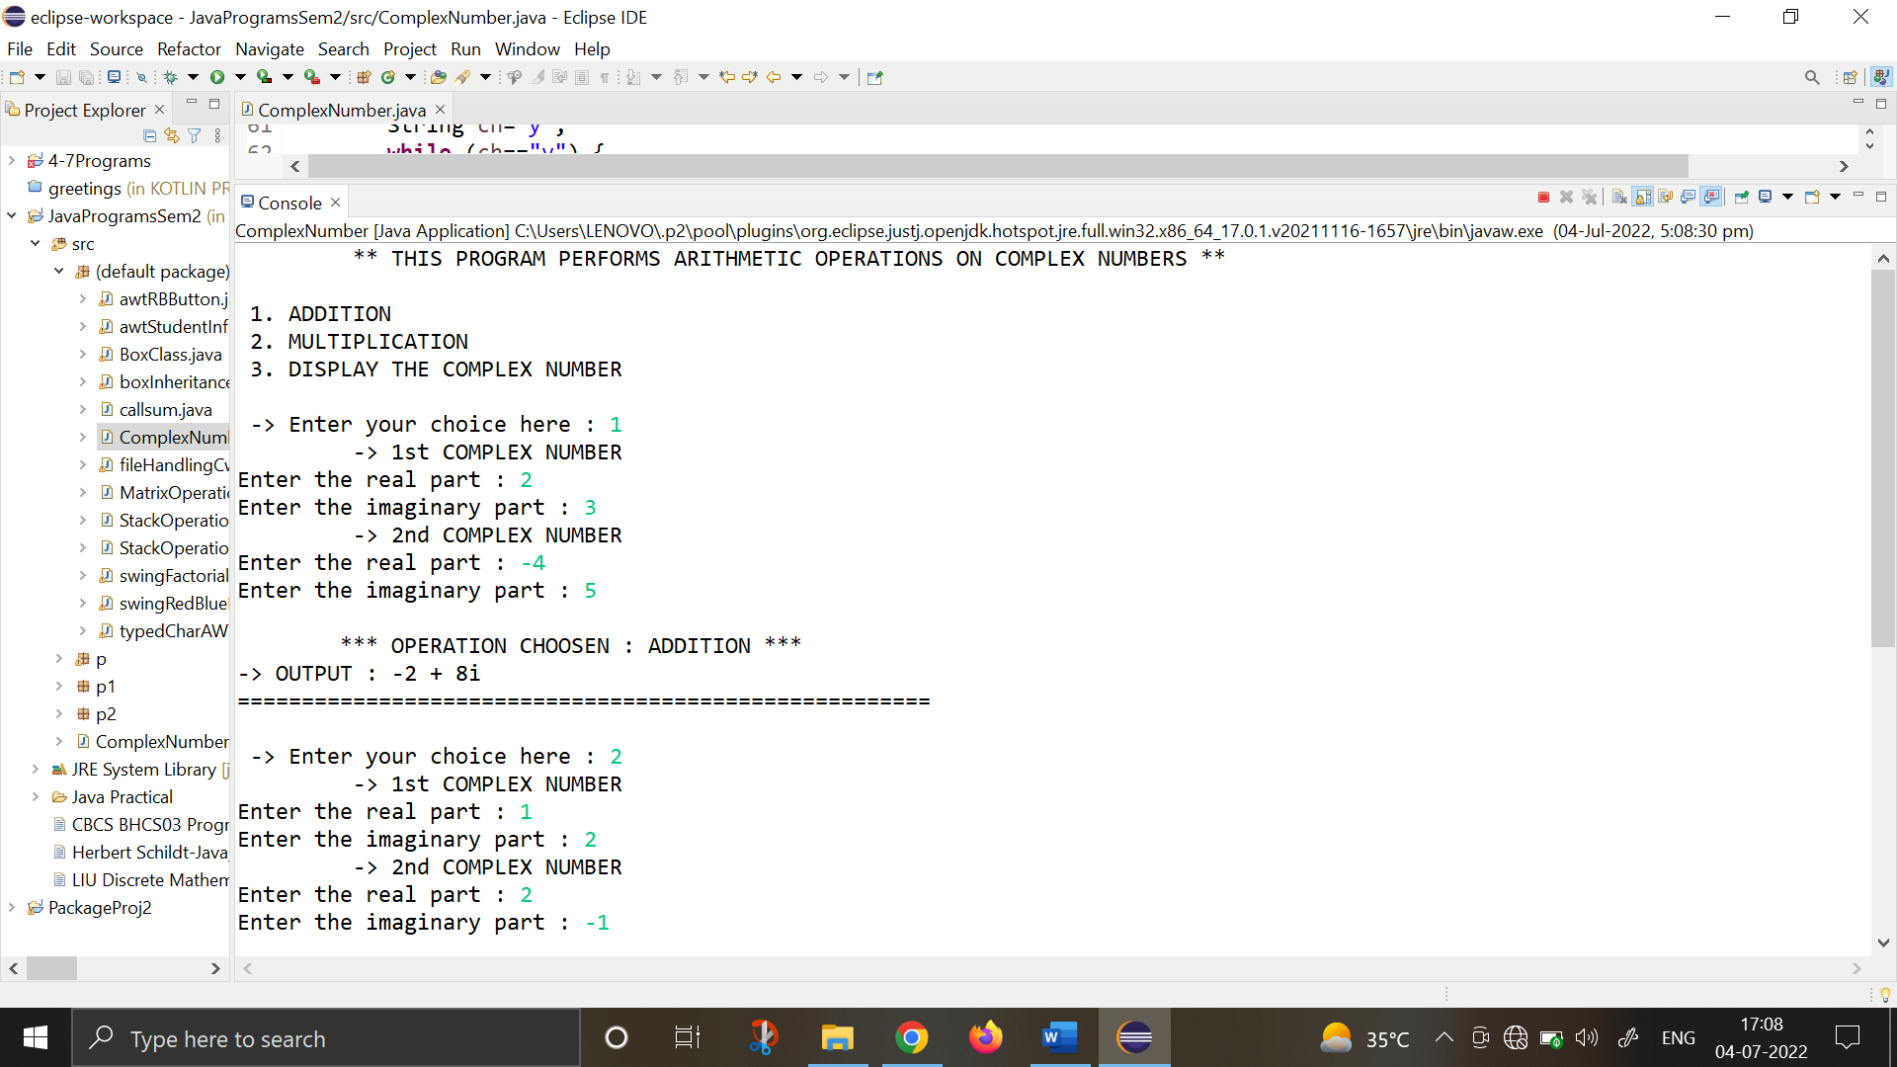

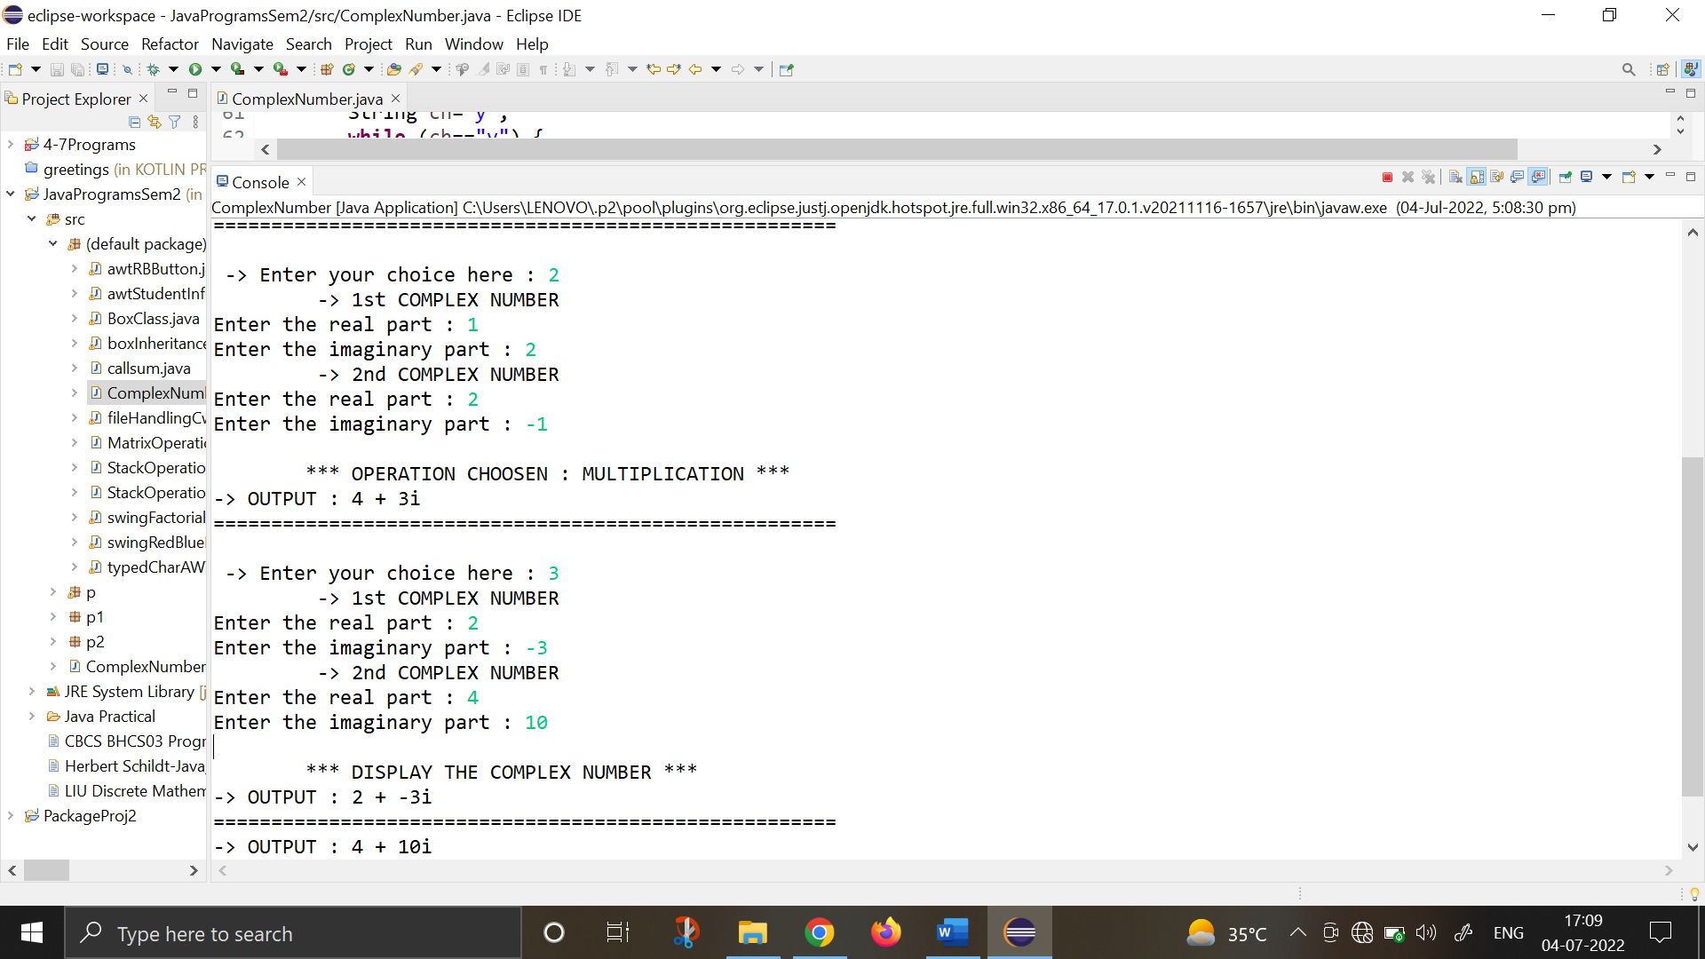

1. **Create a class TwoDim which contains private members as x and y coordinates in package P1. Define the default constructor, a parameterized constructor and override toString() method to display the co-ordinates. Now reuse this class and in package P2 create another class ThreeDim, adding a new dimension as z as its private member. Define the constructors for the subclass and override toString() method in the subclass also. Write appropriate methods to show dynamic method dispatch. The main() function should be in a package P.**

**Package P1**

**package** p1;

**public** **class** twodim {

**int** x, y;

**public** twodim() {

x=y=0;

}

**public** twodim(**int** i, **int** j){

x=i;

y=j;

}

**public** String toString(){

**return** ("\n\t-> THE COORDINATES ARE : "+x+" , "+y);

}

}

**Package P2**

**package** p2;

**import** p1.twodim;

**public** **class** threedim **extends** twodim{

**int** z;

**public** threedim(){

**super**();

z=0;

}

**public** threedim(**int** i, **int** j, **int** k){

**super**(i,j);

z=k;

}

**public** String toString() {

**return** **super**.toString()+" and "+z;

}

}

**Package P : main() function**

**package** p;

**import** java.io.*;

**import** p1.twodim;

**import** p2.threedim;

**public** **class** coordMain {

**public** **static** **void** main(String[] args)**throws** IOException{

BufferedReader br=**new** BufferedReader(**new** InputStreamReader(System.***in***));

System.***out***.println("\t ================================================");

System.***out***.println("\t THE PROGRAM STORES 2D & 3D COORDINATES ");

System.***out***.println("1. 2-Dimensional \n2. 3-Dimensional ");

**int** choice;

**int** a,b,c;

String output;

String ch="y";

**while** (ch.equals("y")) {

System.***out***.println("\t ================================================");

System.***out***.print("-> Enter your choice(1,2) : ");

choice=Integer.*parseInt*(br.readLine());

**switch**(choice) {

**case** 1: System.***out***.println("\n\t ** 2 DIMENSION CHOOSEN ** ");

System.***out***.print("- Enter x coordinate: ");

a=Integer.*parseInt*(br.readLine());

System.***out***.print("- Enter y coordinate: ");

b=Integer.*parseInt*(br.readLine());

twodim o1=**new** twodim(a,b);

output=o1.toString();

System.***out***.println(output);

**break**;

**case** 2: System.***out***.println("\n\t ** 3 DIMENSION CHOOSEN ** ");

System.***out***.print("- Enter x coordinate: ");

a=Integer.*parseInt*(br.readLine());

System.***out***.print("- Enter y coordinate: ");

b=Integer.*parseInt*(br.readLine());

System.***out***.print("- Enter z coordinate: ");

c=Integer.*parseInt*(br.readLine());

threedim o2=**new** threedim(a,b,c);

output=o2.toString();

System.***out***.println(output);

**break**;

**default** : System.***out***.println("Invalid Choice! Try again. \n");

}

System.***out***.print("\nDo you want to continue(y/n) : ");

ch=br.readLine();

}

System.***out***.print("\n PROGRAM ENDS HERE! ");

}

}

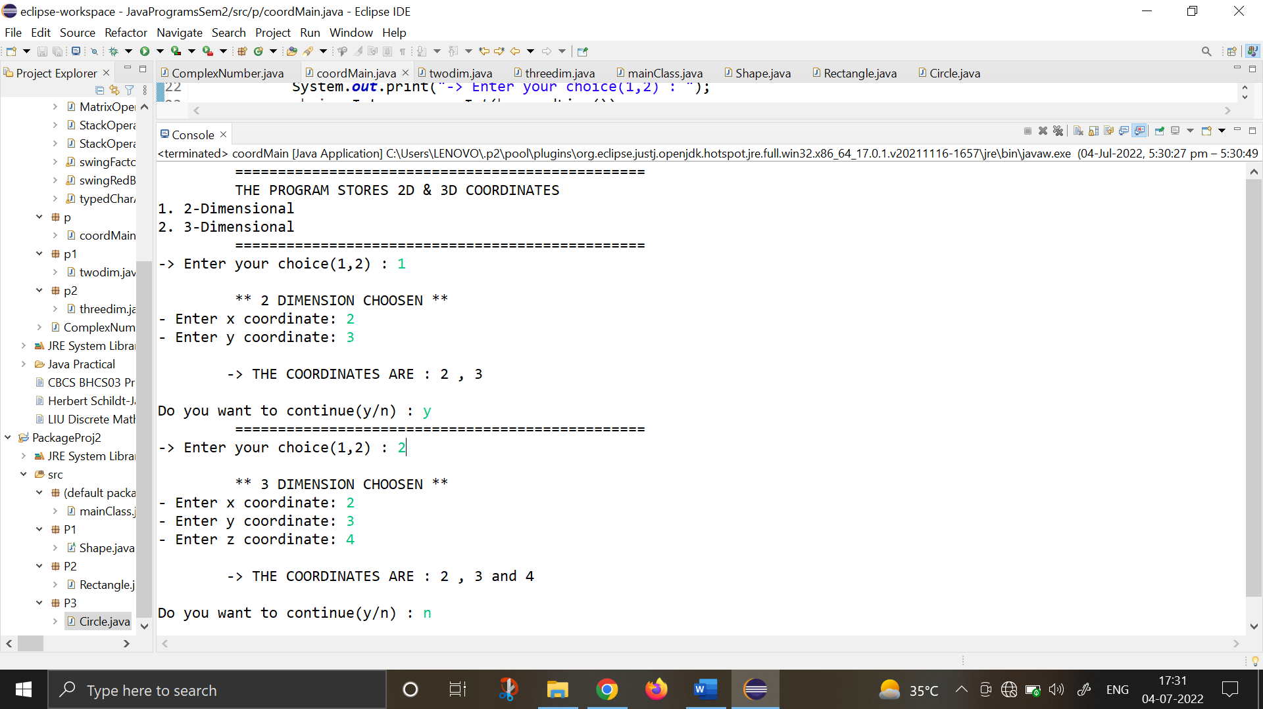

1. **Define an abstract class Shape in package P1. Inherit two more classes: Rectangle in package P2 and Circle in package P3. Write a program to ask the user for the type of shape and then using the concept of dynamic method dispatch, display the area of the appropriate subclass. Also write appropriate methods to read the data. The main() function should not be in any package.**

**Package P1**

**package** P1;

**public** **abstract** **class** Shape {

**public** **double** area;

**public** **abstract** **void** computeArea();

**public** **void** display() {

System.***out***.println(area);

}

}

**Package P2**

**package** P2;

**import** P1.Shape;

**import** java.io.*;

**public** **class** Rectangle **extends** Shape {

**double** length, breadth;

**public** **void** input() **throws** IOException {

BufferedReader br=**new** BufferedReader(**new** InputStreamReader(System.***in***));

System.***out***.print("Enter the length and breadth : ");

length=Integer.*parseInt*(br.readLine());

breadth=Integer.*parseInt*(br.readLine());

}

**public** Rectangle() {

length=breadth=0;

}

**public** Rectangle(**double** a, **double** b) {

length=a;

breadth=b;

}

**public** **void** computeArea() {

area=length*breadth;

}

**public** **void** display() {

System.***out***.print("Rectange Area is as follows : ");

**super**.display();

}

}

**Package P3**

**package** P3;

**import** java.io.*;

**import** P1.Shape;

**public** **class** Circle **extends** Shape{

**double** radius;

**public** Circle() {

radius=0;

}

**public** Circle(**double** r) {

radius=r;

}

**public** **void** input() **throws** IOException {

BufferedReader br=**new** BufferedReader(**new** InputStreamReader(System.***in***));

System.***out***.print("Enter the radius : ");

radius=Integer.*parseInt*(br.readLine());

}

**public** **void** computeArea() {

area=22/7*radius*radius;

}

**public** **void** display() {

System.***out***.print("Circle Area is as follows : ");

**super**.display();

}

}

**Default Package - MAIN() FUNCTION :**

**import** P1.Shape;

**import** P2.Rectangle;

**import** P3.Circle;

**import** java.io.*;

**public** **class** mainClass {

**public** **static** **void** main(String[] args)**throws** IOException{

BufferedReader br=**new** BufferedReader(**new** InputStreamReader(System.***in***));

System.***out***.println("\t ================================================");

System.***out***.println("\t THE PROGRAM CALCULATES THE AREA OF SHAPES ");

System.***out***.println("1. Rectangle \n2. Circle ");

**int** choice;

Shape obj;

String ch="y";

**while** (ch.equals("y")) {

System.***out***.println("\t ================================================");

System.***out***.print("-> Enter your choice(1,2) : ");

choice=Integer.*parseInt*(br.readLine());

**switch**(choice) {

**case** 1: System.***out***.println("\n\t ** SHAPE CHOOSEN : RECTANGLE ** ");

Rectangle o1=**new** Rectangle();

o1.input();

obj=o1;

obj.computeArea();

obj.display();

**break**;

**case** 2: System.***out***.println("\n\t ** SHAPE CHOOSEN : CIRCLE ** ");

Circle o2=**new** Circle();

o2.input();

obj=o2;

obj.computeArea();

obj.display();

**break**;

**default** : System.***out***.println("Invalid Choice! Try again. \n");

}

System.***out***.print("\nDo you want to continue(y/n) : ");

ch=br.readLine();

}

System.***out***.print("\n PROGRAM ENDS HERE! ");

}

}

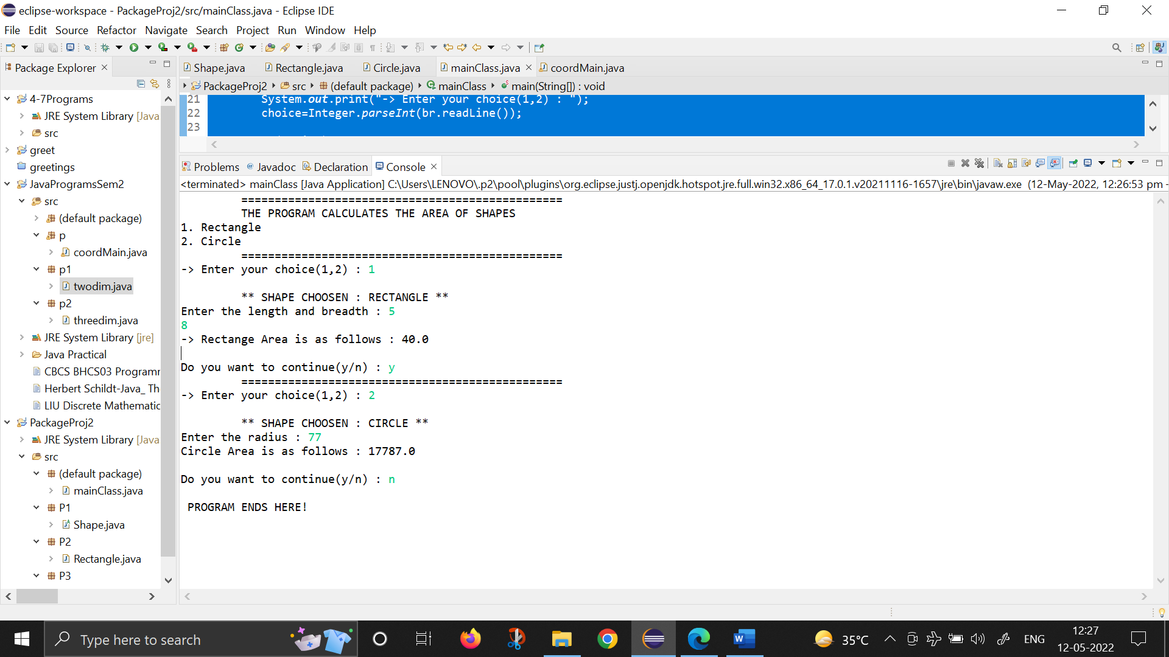

1. **Create an exception subclass UnderAge, which prints “Under Age” along with the age value when an object of UnderAge class is printed in the catch statement. Write a class exceptionDemo in which the method test() throws UnderAge exception if the variable age passed to it as argument is less than 18. Write main() method also to show working of the program.**

import java.io.*;

class exceptionDemo extends Exception{

private int num;

public exceptionDemo(int a){

num=a;

}

public String toString() {

String op="Exception: UnderAge ; Age: "+num;

return op;

}

}

public class Ques4L{

public static String test(int a) throws exceptionDemo{

if (a<18) {

throw new exceptionDemo(a);

}

return " Age: "+a;

}

public static void main(String[] args) throws IOException, Exception {

System.out.println("\t **PROGRAM TO CHECK THE INPUT AGE \n\t\t WITH EXCEPTION HANDLING**");

BufferedReader br=new BufferedReader(new InputStreamReader(System.in));

int input;

String result;

String ch="y";

while (ch.equals("y")) {

System.out.print("\n-> Enter the Age : ");

input=Integer.parseInt(br.readLine());

try {

result=test(input);

System.out.println(result);

} catch(exceptionDemo e) {

System.out.println("Caught "+e);

}

System.out.print("\nDo you want to continue(y/n) : ");

ch=br.readLine();

}

System.out.println("\n*** PROGRAM ENDS HERE! ***");

}

}

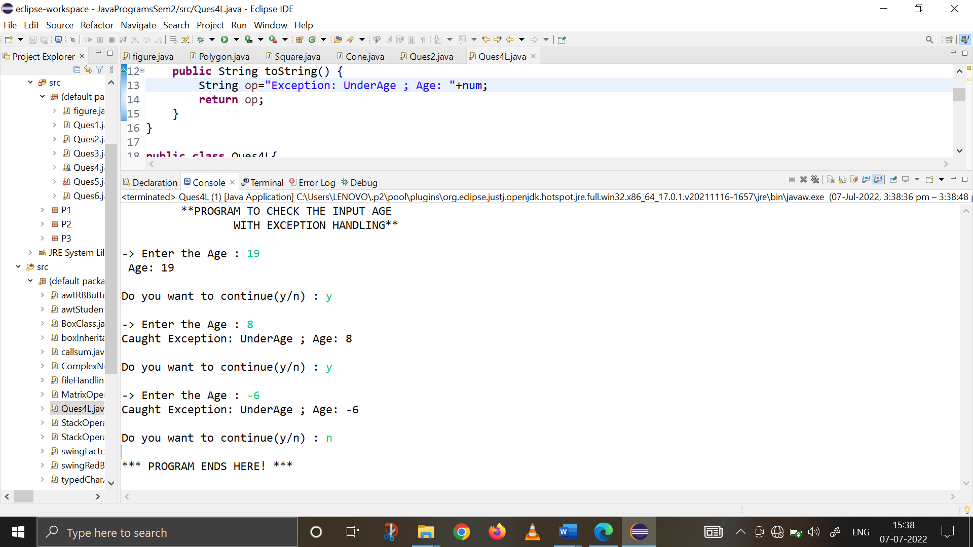

1. **Write a program to implement stack. Use exception handling to manage underflow and overflow conditions**

**import** java.io.*;

**class** STACK1 {

**int** list[], size;

**int** tos=-1;

STACK1(**int** num){

size=num;

list= **new** **int**[size];

}

**void** push(**int** n){

**try** {

**if** (tos==size-1)

**throw** **new** Exception("STACK OVERFLOW");

list[++tos]=n;

}

**catch** (Exception o1) {

System.***out***.println("Element added to stack is :"+o1);

}

}

**int** pop(){

**try** {

**if** (tos==-1)

**throw** **new** Exception("STACK UNDERFLOW");

**return** list[tos--];

}

**catch**(Exception o1) {

**return** -1;

}

}

**void** displayStack(){

System.***out***.println("\t -> THE STACK ELEMENTS ARE : ");

**for** (**int** i=0; i<size; i++) {

System.***out***.print("\t"+list[i]);

}

}

}

**public** **class** StackOperationsWithExceptions {

**public** **static** **void** main(String[] args) **throws** IOException {

BufferedReader br1=**new** BufferedReader(**new** InputStreamReader(System.***in***));

**int** stackSize, choice, num;

System.***out***.println("\t ** STACK AND STACK OPERATIONS ** \n");

System.***out***.println("CREATING A EMPTY STACK");

System.***out***.print("Enter the size of the Stack : ");

stackSize=Integer.*parseInt*(br1.readLine());

System.***out***.println("\n -> A Stack with "+stackSize+" integers will be created!");

STACK1 s1;

s1= **new** STACK1(stackSize);

System.***out***.println("\nPERFORMING STACK OPERATIONS\n");

System.***out***.println("1. PUSH the elements in Stack ");

System.***out***.println("2. POP the elements from Stack ");

System.***out***.println("3. Display all the elements from Stack ");

String ch="y";

**while** (ch.equals("y")) {

System.***out***.print("\n ** Enter the stack operation you want to perform (1,2,3) : ");

choice=Integer.*parseInt*(br1.readLine());

**switch**(choice){

**case** 1 : System.***out***.println("\n\t -> OPERATION CHOOSEN : PUSH ");

**for** (**int** i=1; i<=stackSize; i++) {

System.***out***.print("Enter the "+i+" element : ");

num=Integer.*parseInt*(br1.readLine());

s1.push(num);

}

**break**;

**case** 2 : System.***out***.println("\n\t -> OPERATION CHOOSEN : POP ");

**for** (**int** i=1; i<=stackSize; i++) {

**int** x=s1.pop();

System.***out***.println("The popped element : "+x);

}

**break**;

**case** 3 : System.***out***.println("\n\t -> OPERATION CHOOSEN : DISPLAY STACK ");

s1.displayStack();

}

System.***out***.print("\n Do you want to continue(y/n)? ");

ch=br1.readLine();

}

System.***out***.println("\n \t ** PROGRAM ENDS HERE ** ");

}

}

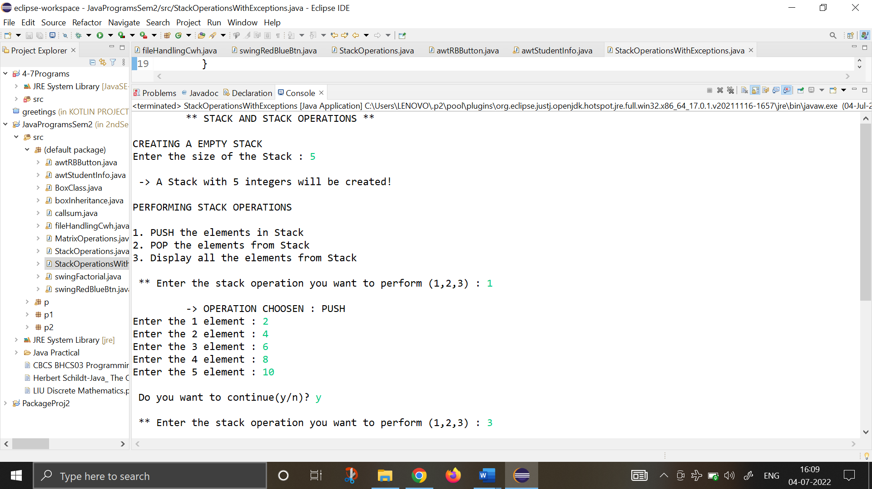

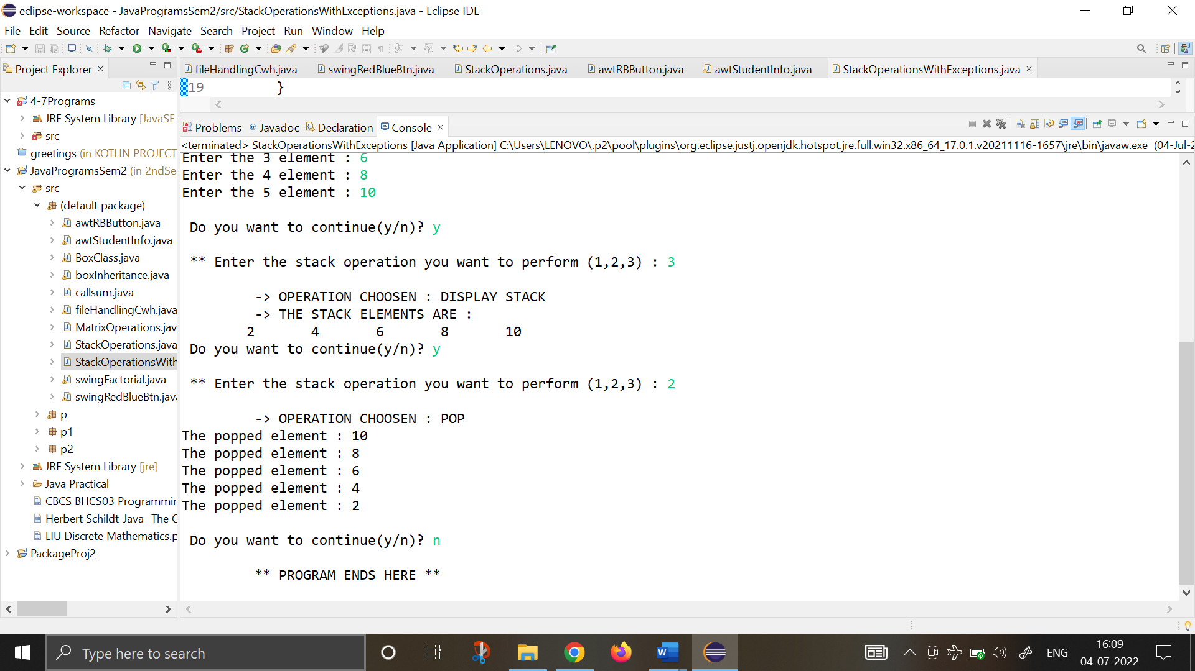

1. **Write a program that copies content of one file to another. Pass the names of the files through command-line arguments.**

**import** java.io.*;

**public** **class** Ques6 {

**public** **static** **void** main(String[] args) **throws** IOException

{

System.***out***.println("\t** PROGRAM TO COPY THE CONTENTS OF FILE **\n ");

**int** i;

FileInputStream fin = **null**;

FileOutputStream fout = **null**;

**if**(args.length != 2) {

System.***out***.println("Enter the arguments");

**return**;

}

**try** {

fin = **new** FileInputStream(args[0]);

fout = **new** FileOutputStream(args[1]);

**do** {

i= fin.read();

**if**(i != -1)

{

fout.write(i);

}

}**while**(i != -1);

System.***out***.println("-> SOURCE FILE (Using CommandLine): "+args[0]);

System.***out***.println("-> DESTINATION FILE (Using CommandLine): "+args[1]);

System.***out***.println("\n-> File copied Successfully!");

}

**catch**(IOException e)

{

System.***out***.println("-> I/O Error :"+e);

}

}

}

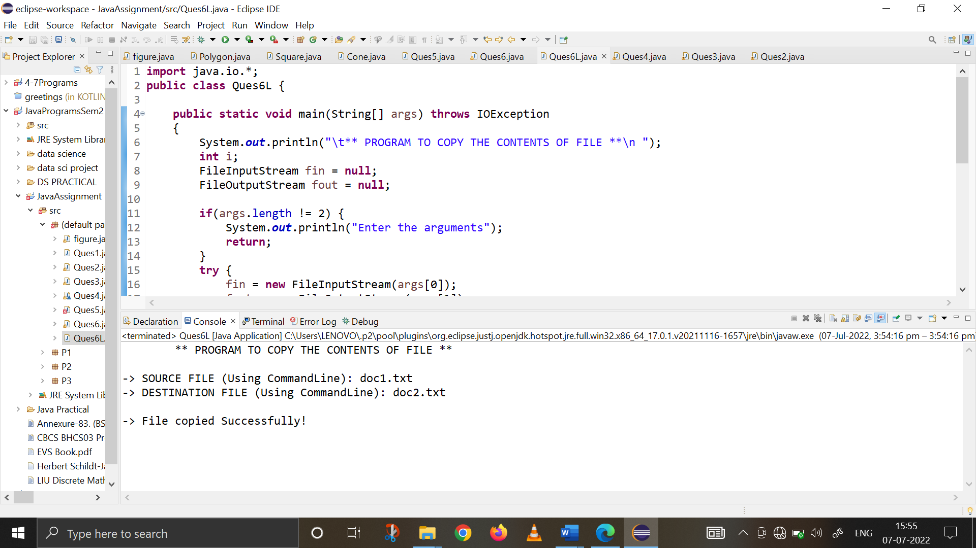

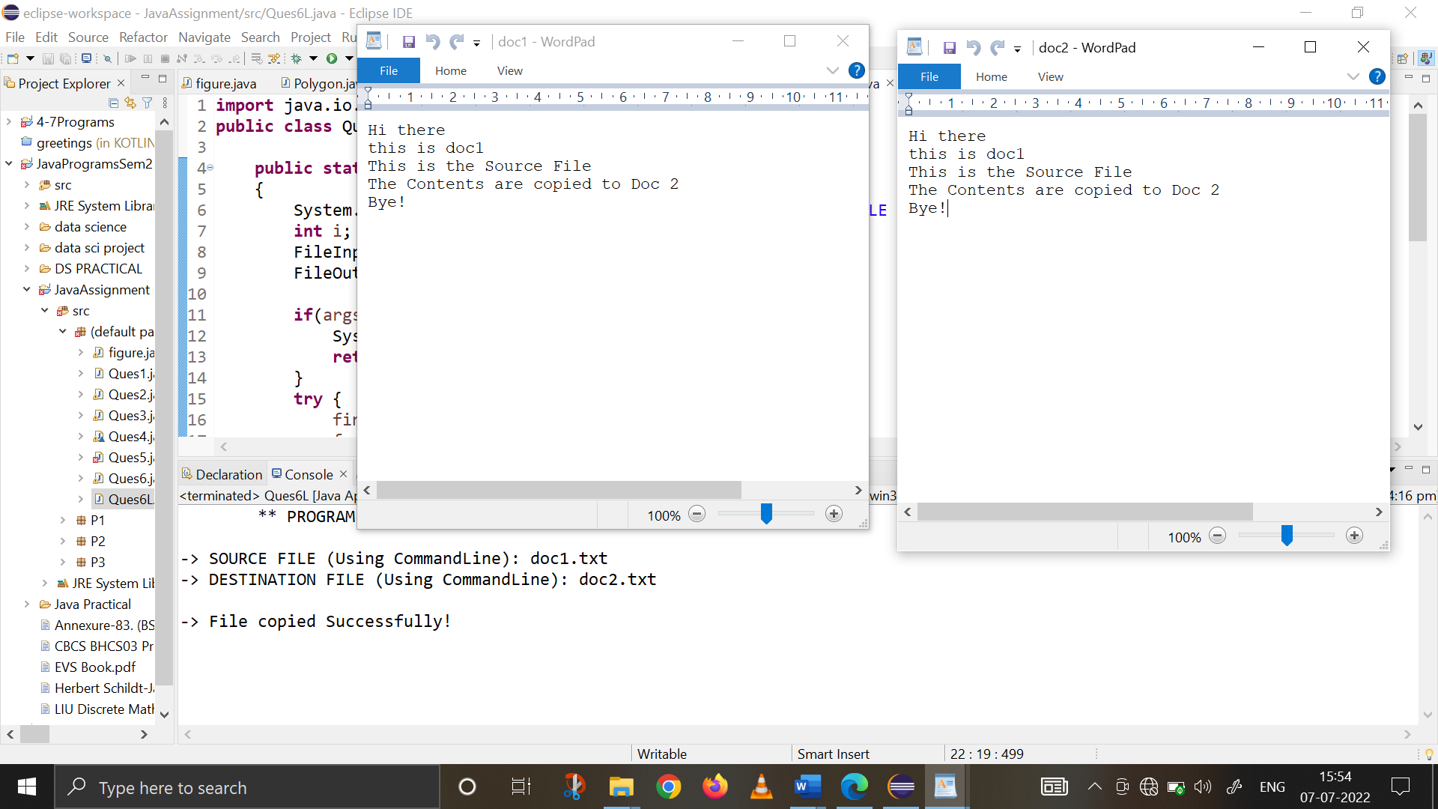

1. **Write a program to read a file and display only those lines that have the first two characters as '//' (Use try with resources).**

**import** java.io.*;

**public** **class** Ques7L {

**public** **static** **void** main(String[] args)**throws** IOException

{

FileInputStream o1= **new** FileInputStream("doc1.txt");

**int** x= o1.read();

**while**(x!=-1) {

**char** x1=(**char**)x;

**char** y=(**char**)o1.read();

**char** ch=(**char**)o1.read();

**if**(x1=='/' && y=='/')

{

**while**(ch!='\n')

{

System.***out***.print(ch);

ch=(**char**)o1.read();

}

System.***out***.print(ch);

}

**else**

{

**while**(ch!='\n')

{

ch=(**char**) o1.read();

}

}

x=o1.read();

}

o1.close();

}

}

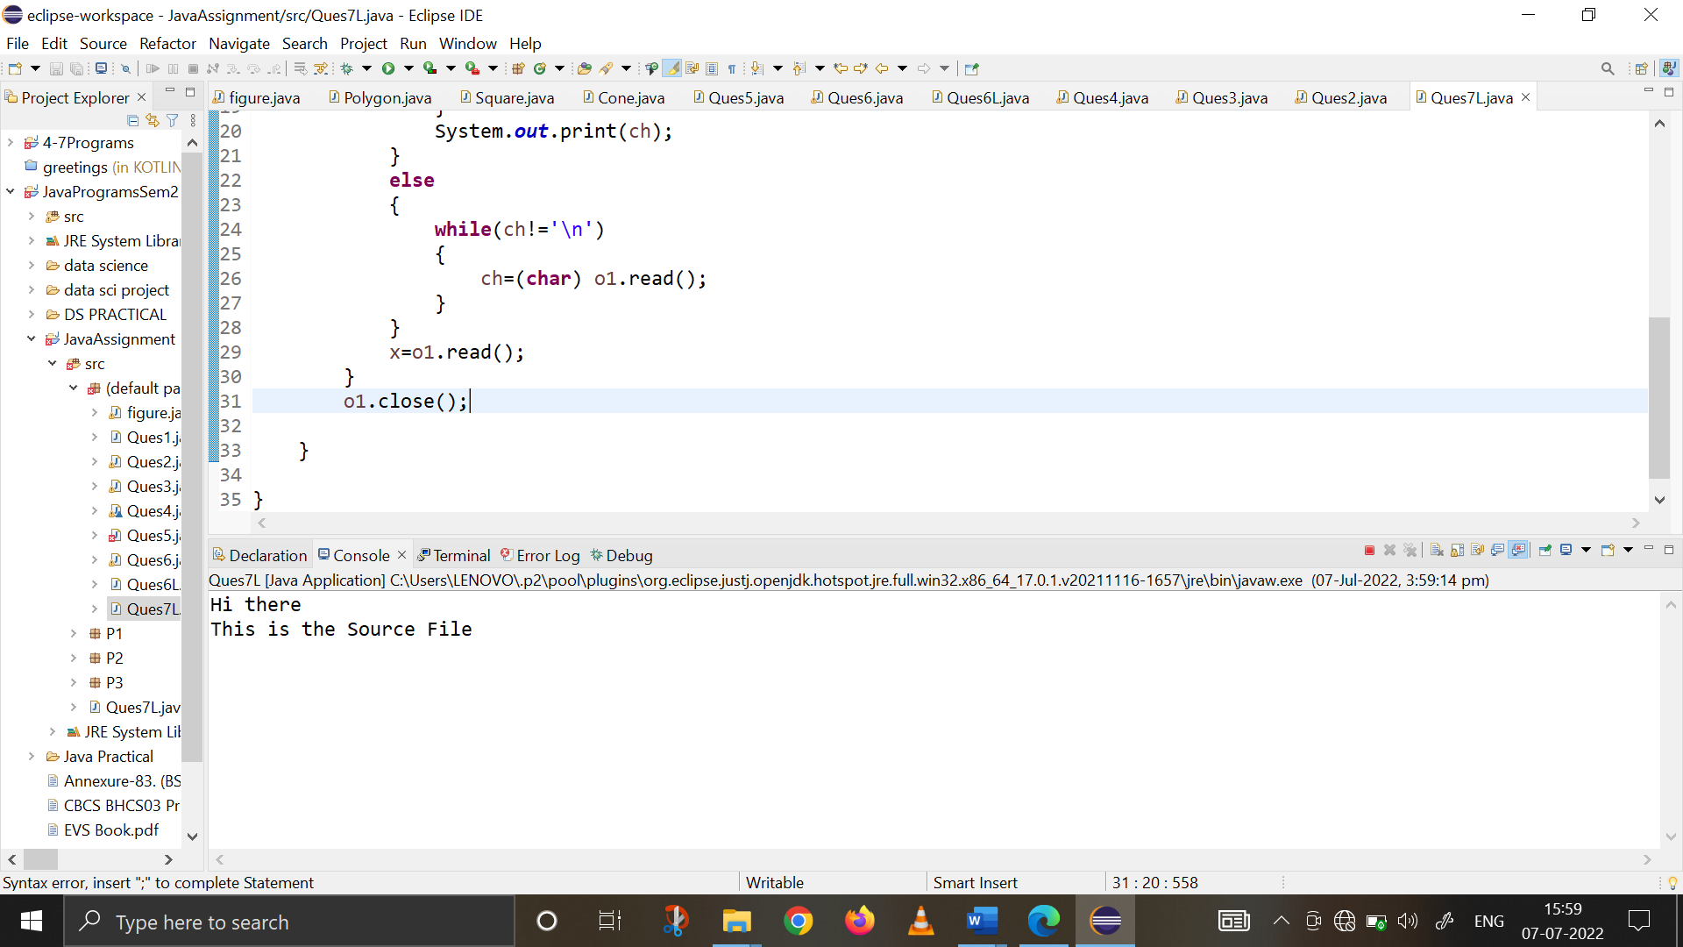 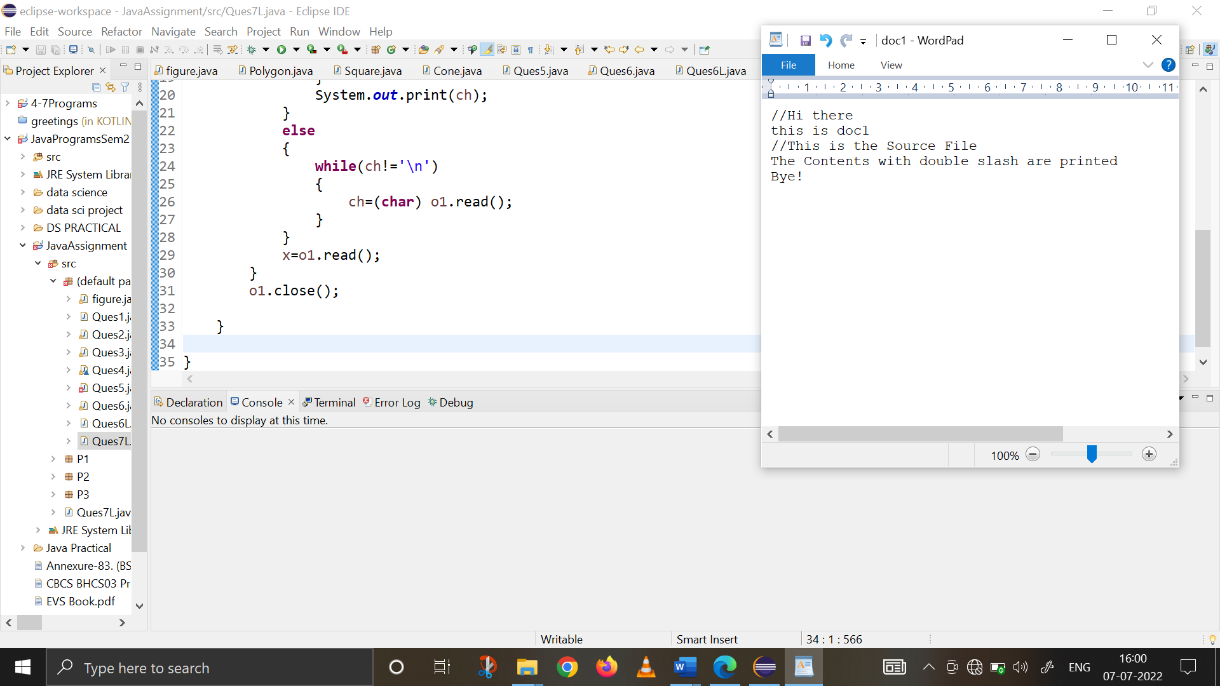

1. **Write a program to create a frame using AWT. Implement mouseClicked(), mouseEntered() and mouseExited() events such that:**

**a) Size of the frame should be tripled when mouse enters it.**

**b) Frame should reduce to its original size when mouse is clicked in it.**

**c) Close the frame when mouse exits it.**

**import java.awt.*;**

**import java.awt.event.*;**

**public class MouseEvents extends Frame{**

**Dimension o1;**

**public MouseEvents() {**

**setSize(new Dimension(300,300));**

**o1=getSize();**

**addMouseListener(new MyMouseAdapter(this));**

**}**

**public static void main(String[] args) {**

**MouseEvents o1 = new MouseEvents();**

**o1.setTitle("Mouse Events Frame : Ques 8");**

**o1.setVisible(true);**

**}**

**class MyMouseAdapter extends MouseAdapter{**

**MouseEvents f1;**

**public MyMouseAdapter(MouseEvents o1) {**

**f1=o1;**

**}**

**public void mouseEntered(MouseEvent me) {**

**int h,w;**

**Dimension dl=f1.getSize();**

**h=dl.height*3;**

**w=dl.width*3;**

**f1.setSize(h,w);**

**}**

**public void mouseClicked(MouseEvent me) {**

**f1.setSize(o1.height, o1.width);**

**}**

**public void mouseExited(MouseEvent me) {**

**System.*exit*(0);**

**}**

**}**

**}**

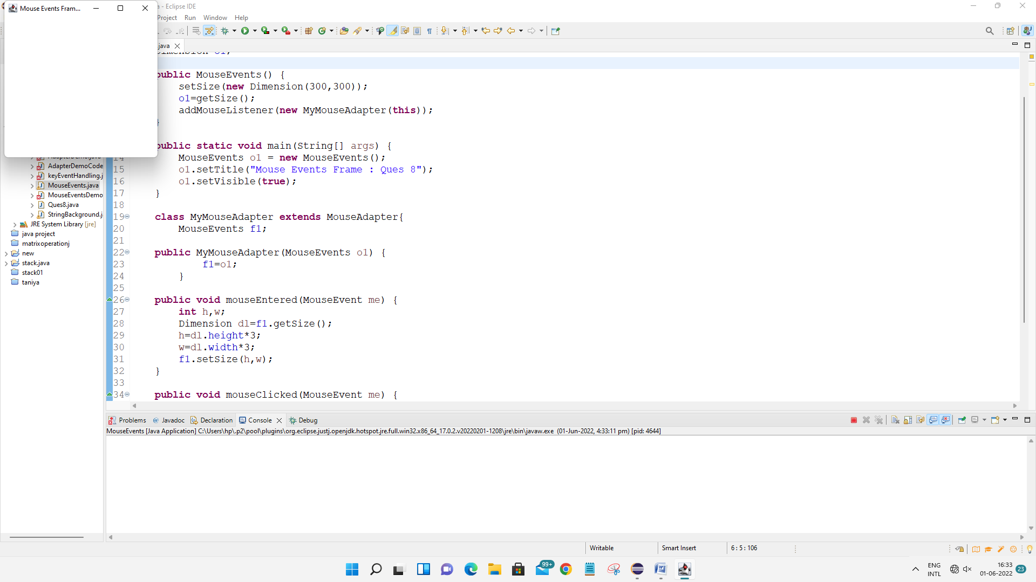

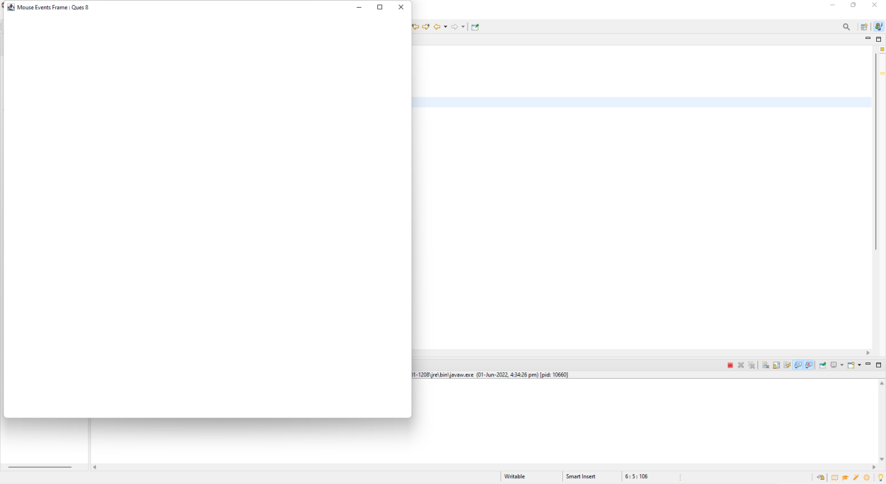

1. **Using AWT, write a program to display a string in frame window with pink color as background.**

**import java.awt.*;**

**import java.awt.event.*;**

**public class StringBackground extends Frame{**

**Dimension o1;**

**public StringBackground() {**

**setSize(800,800);**

**setBackground(Color.*pink*);**

**addWindowListener(new MyWindowAdapter());**

**}**

**public void paint(Graphics g) {**

**g.drawString("Hello World!", 300 , 300);**

**}**

**public static void main(String[] args) {**

**StringBackground o1 = new StringBackground();**

**o1.setTitle("QUESTION 9");**

**o1.setVisible(true);**

**}**

**class MyWindowAdapter extends WindowAdapter{**

**public void windowClosing(WindowEvent o1) {**

**System.*exit*(0);**

**}**

**}**

**}**

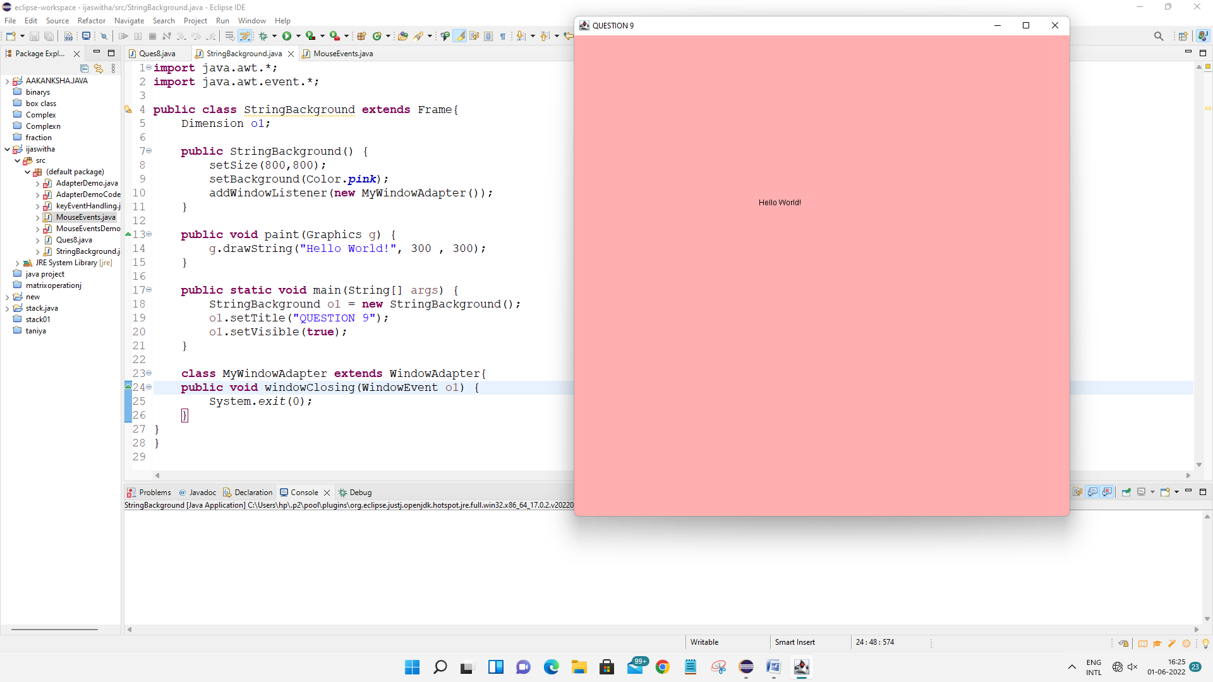

1. **Using AWT, write a program to create two buttons named “Red” and “Blue”. When a button is pressed the background color should be set to the color named by the button’s label.**

**import** java.awt.*;

**import** java.awt.event.*;

**public** **class** awtRBButton **extends** Frame **implements** ActionListener {

Button red,blue;

**public** awtRBButton()

{

setLayout(**new** FlowLayout());

red=**new** Button("RED");

blue=**new** Button("BLUE");

add(red);

add(blue);

red.addActionListener(**this**);

blue.addActionListener(**this**);

addWindowListener(**new** WindowAdapter() {

**public** **void** windowClosing(WindowEvent we ) {

System.*exit*(0);

}

});

}

**public** **void** actionPerformed(ActionEvent e1) {

String s=e1.getActionCommand();

**if**(s.equals("RED"))

{

setBackground(Color.***red***);

}

**else**

**if**(s.equals("BLUE"))

{

setBackground(Color.***blue***);

}

}

**public** **static** **void** main(String[] args) {

awtRBButton o1=**new** awtRBButton();

o1.setSize(**new** Dimension(500,500));

o1.setTitle("Question 10 : Red Blue Button ");

o1.setVisible(**true**);

}

}

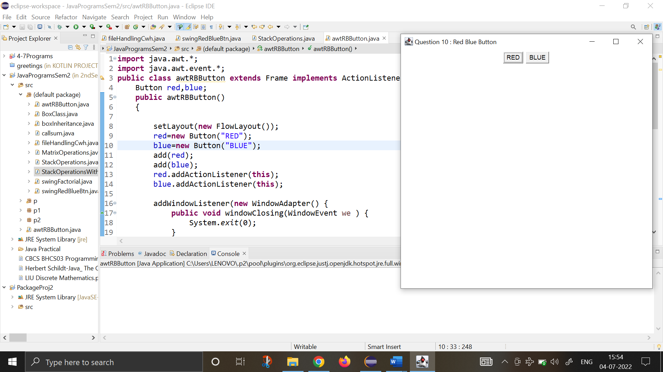

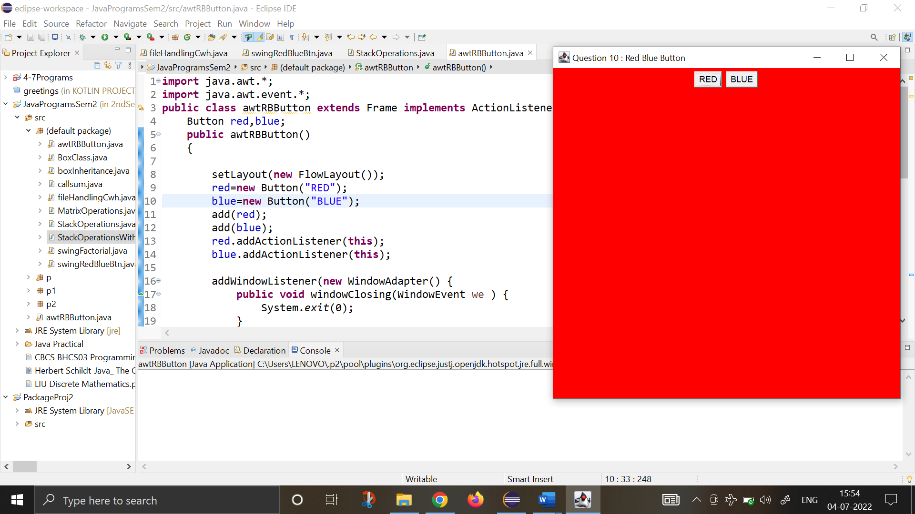

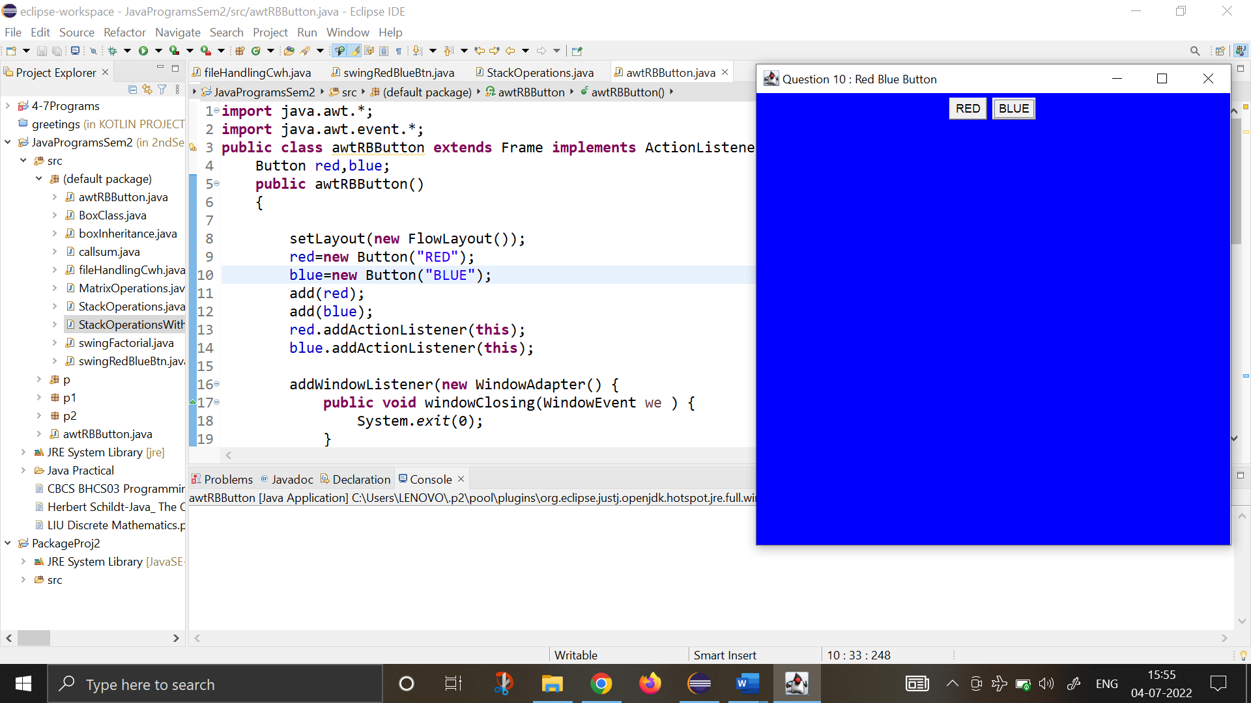

1. **Using AWT, write a program using appropriate adapter class to display the message (“Typed character is: ”) in the frame window when user types any key.**

**import** java.awt.*;

**import** java.awt.event.*;

**public** **class** typedCharAWT **extends** Frame {

String msg = " Typed character is :- ";

**public** typedCharAWT()

{

setLayout(**new** FlowLayout());

addKeyListener(**new** MyKeyAdapter(**this**));

addWindowListener(**new** MyWindowAdapter());

}

**public** **void** paint(Graphics g)

{

g.drawString(msg, 100, 100);

}

**public** **static** **void** main(String[] args) {

// **TODO** Auto-generated method stub

typedCharAWT o1 = **new** typedCharAWT();

o1.setSize(**new** Dimension(500,200));

o1.setTitle(" List question number 11 ");

o1.setVisible(**true**);

}

}

**class** MyKeyAdapter **extends** KeyAdapter{

typedCharAWT o2;

**public** MyKeyAdapter(typedCharAWT o2) {

**this**.o2=o2;

}

**public** **void** keyTyped(KeyEvent k) {

o2.msg += k.getKeyChar();

o2.repaint();

}

}

**class** MyWindowAdapter **extends** WindowAdapter{

**public** **void** windowClosing(WindowEvent we) {

System.*exit*(0);

}

}

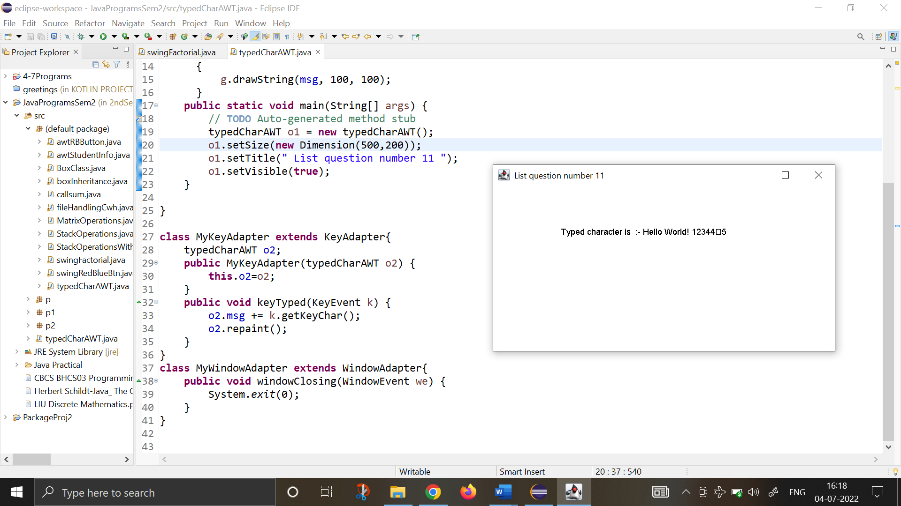

1. **Using AWT, write a program to create two buttons labelled ‘A’ and ‘B’. When button ‘A’ is pressed, it displays your personal information (Name, Course, Roll No, College) and when button ‘B’ is pressed, it displays your CGPA in previous semester.**

**import** java.awt.*;

**import** java.awt.event.*;

**public** **class** awtStudentInfo **extends** Frame **implements** ActionListener {

Button A,B;

String msg1 = "",msg2="",msg3="",msg4="";

**public** awtStudentInfo() {

setLayout(**new** FlowLayout());

A=**new** Button("A");

B=**new** Button("B");

add(A);

add(B);

A.addActionListener(**this**);

B.addActionListener(**this**);

addWindowListener(**new** WindowAdapter() {

**public** **void** windowClosing(WindowEvent we ) {

System.*exit*(0);

}

});

}

**public** **void** actionPerformed(ActionEvent e2) {

String s=e2.getActionCommand();

**if**(s.equals("A"))

{

msg1= " NAME - KHUSHI PANWAR ";

msg2 = " COURSE - COMPUTER SCIENCE ";

msg3 = " ROLL NUMBER - 2021334";

msg4 = " COLLEGE NAME - SRCAS-W";

}

**else** **if**(s.equals("B"))

{msg1= " CGPA in previous semester :- 9 ";

msg2= "";

msg3= "";

msg4= "";

}

repaint();

}

**public** **void** paint(Graphics g)

{

g.drawString(msg1, 20, 100);

g.drawString(msg2, 20, 130);

g.drawString(msg3, 20, 160);

g.drawString(msg4, 20, 190);

}

**public** **static** **void** main(String[] args) {

awtStudentInfo o1=**new** awtStudentInfo();

o1.setSize(**new** Dimension(600, 600));

o1.setTitle(" List question number 12 ");

o1.setVisible(**true**);

}

}

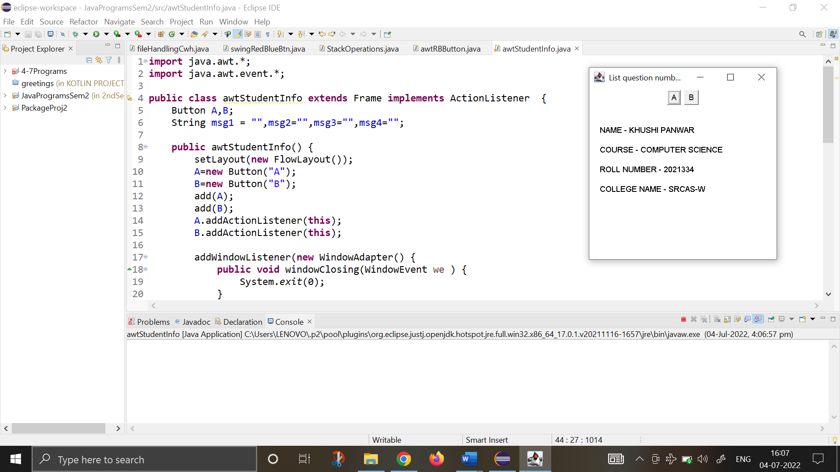

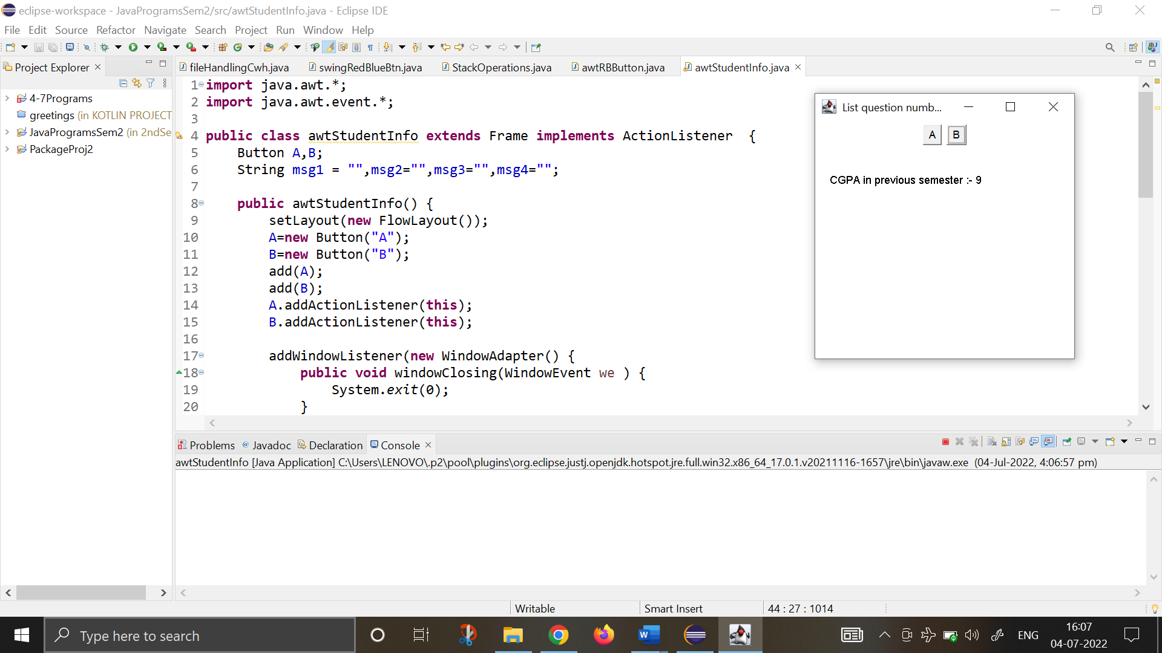

1. **Rewrite all the above GUI programs using Swing.**
2. **Write a program to create a frame using AWT. Implement mouseClicked(), mouseEntered() and mouseExited() events such that:**

**a) Size of the frame should be tripled when mouse enters it.**

**b) Frame should reduce to its original size when mouse is clicked in it.**

**c) Close the frame when mouse exits it.**

**import** java.awt.*;

**import** java.awt.event.*;

**import** javax.swing.*;

**public** **class** Ques13i{

JFrame o1;

Dimension d;

Ques13i(){

o1=**new** JFrame("QUES 13: MOUSE EVENT HANDLING USING SWING");

o1.setSize(300,300);

d=o1.getSize();

o1.setDefaultCloseOperation(JFrame.***EXIT_ON_CLOSE***);

o1.addMouseListener(**new** MyMouseAdapter1(**this**));

o1.setVisible(**true**);

}

**public** **static** **void** main(String[] args) {

SwingUtilities.*invokeLater*(**new** Runnable() {

**public** **void** run()

{

**new** Ques13i();

}

});

}

}

**class** MyMouseAdapter1 **extends** MouseAdapter

{

Ques13i o2;

MyMouseAdapter1(Ques13i o2)

{

**this**.o2=o2;

}

**public** **void** mouseClicked(MouseEvent m1)

{

o2.o1.setSize(o2.d.width,o2.d.height);

}

**public** **void** mouseEntered(MouseEvent m)

{

Dimension d;

d=o2.o1.getSize();

o2.o1.setSize(d.width*3,d.height*3);

}

**public** **void** mouseExited(MouseEvent m)

{

System.*exit*(0);

}

}

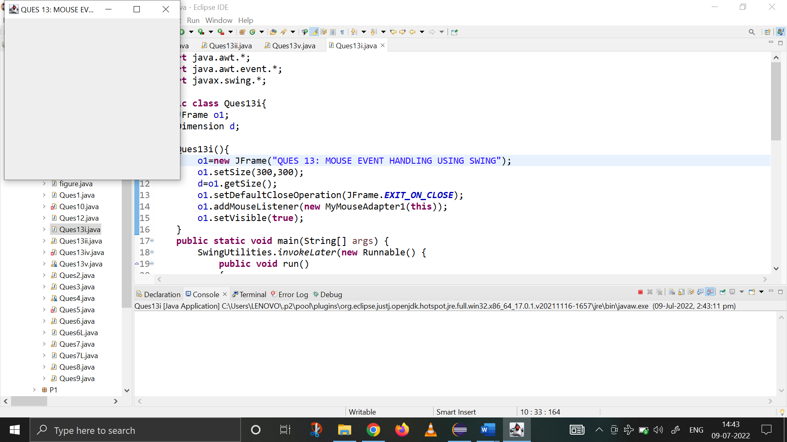

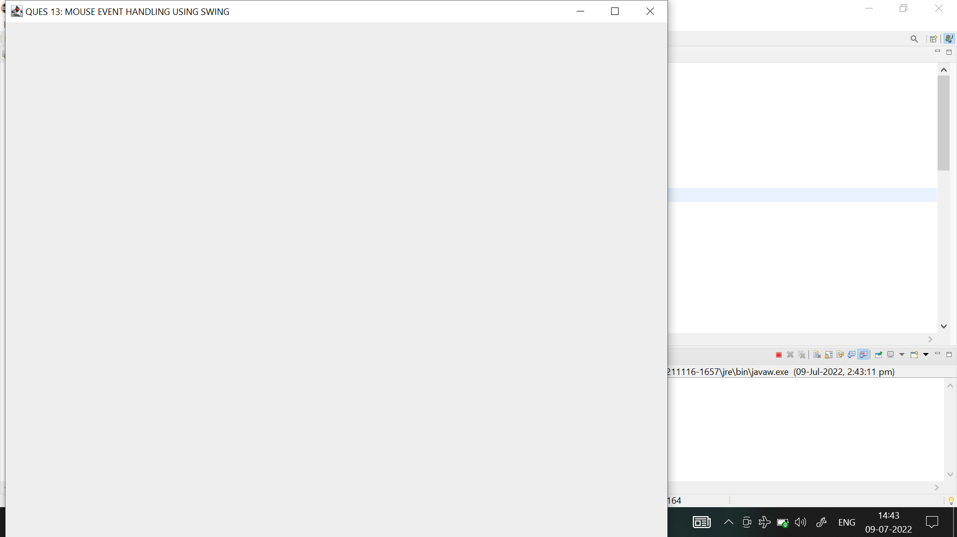

1. **Using SWING, write a program to display a string in frame window with pink color as background.**

**import** java.awt.*;

**import** javax.swing.*;

**public** **class** Ques13ii **extends** JFrame {

JLabel o1;

Ques13ii(){

setSize(400,400);

setDefaultCloseOperation(JFrame.***EXIT_ON_CLOSE***);

getContentPane().setBackground(Color.***pink***);

setLayout(**new** FlowLayout());

o1=**new** JLabel(" Hi There! This is a Java program @_@ ");

getContentPane().add(o1);

setVisible(**true**);

}

**public** **static** **void** main(String[] args) {

SwingUtilities.*invokeLater*(**new** Runnable() {

**public** **void** run(){

**new** Ques13ii();

}

});

}

}

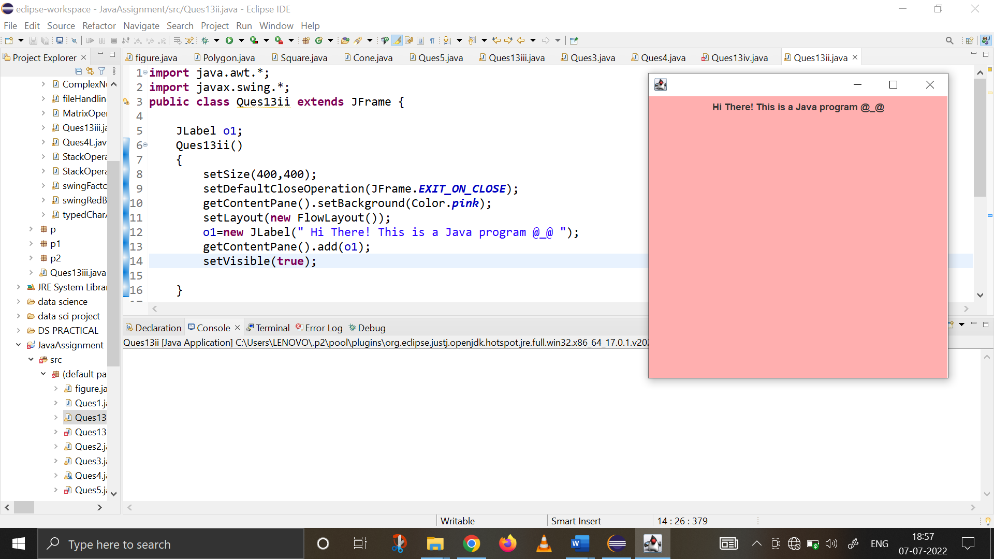

1. **Using SWING, write a program to create two buttons named “Red” and “Blue”. When a button is pressed the background color should be set to the color named by the button’s label.**

**import** java.awt.*;

**import** java.awt.event.*;

**import** javax.swing.*;

**public** **class** Ques13iii {

JLabel jlab;

JFrame jfrm;

JButton jbtnRed, jbtnBlue;

Ques13iii(){

//Basic Frame Settings to set up display window

JFrame jfrm=**new** JFrame("Java Application for Red Blue Button");

JPanel panel=**new** JPanel();

jfrm.getContentPane().setBackground(Color.***WHITE***);

jfrm.setSize(500,500);

jfrm.setVisible(**true**);

jfrm.setLayout(**new** FlowLayout());

jfrm.setDefaultCloseOperation(JFrame.***EXIT_ON_CLOSE***);

//color and button settings

Color c=**new** Color(255,255,255);

JButton jbtnRed=**new** JButton("RED");

jbtnRed.setBackground(Color.***WHITE***);

JButton jbtnBlue=**new** JButton("BLUE");

jbtnBlue.setBackground(Color.***WHITE***);

//adding all components to the frame

jfrm.add(jbtnRed);

jfrm.add(jbtnBlue);

jlab=**new** JLabel("Press a button");

jfrm.add(jlab);

//action listener for red and blue

jbtnRed.addActionListener(**new** ActionListener() {

**public** **void** actionPerformed(ActionEvent ae) {

jfrm.getContentPane().setBackground(Color.***RED***);

jlab.setText("\nRED Button pressed!");

}

});

jbtnBlue.addActionListener(**new** ActionListener() {

**public** **void** actionPerformed(ActionEvent ae) {

jfrm.getContentPane().setBackground(Color.***BLUE***);

jlab.setText("\nBLUE Button pressed!");

}

});

jbtnRed.addActionListener(**new** ActionListener() {

**public** **void** actionPerformed(ActionEvent ae) {

jfrm.getContentPane().setBackground(Color.***BLUE***);

jlab.setText("BLUE Button pressed!");

}

});

}

**public** **static** **void** main(String[] args) {

SwingUtilities.*invokeLater*(**new** Runnable() {

**public** **void** run() {

**new** Ques13iii();

}

});

}

}

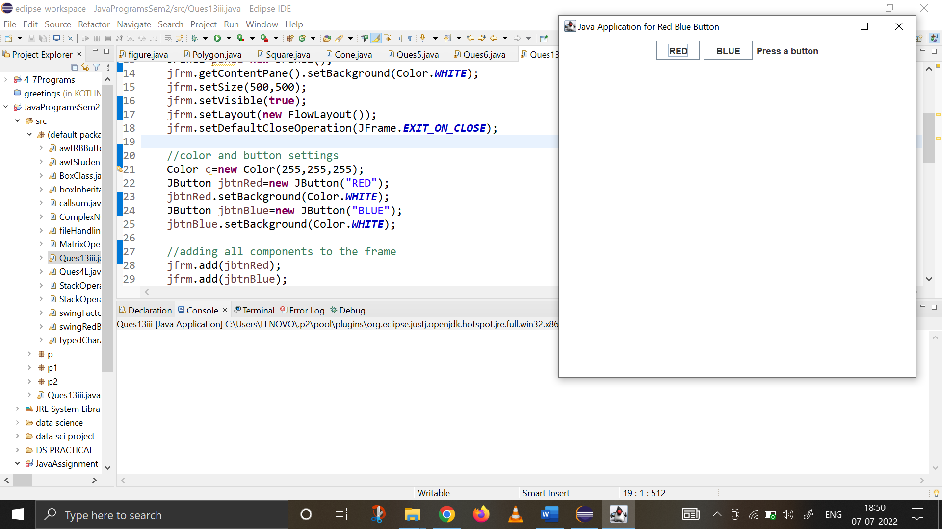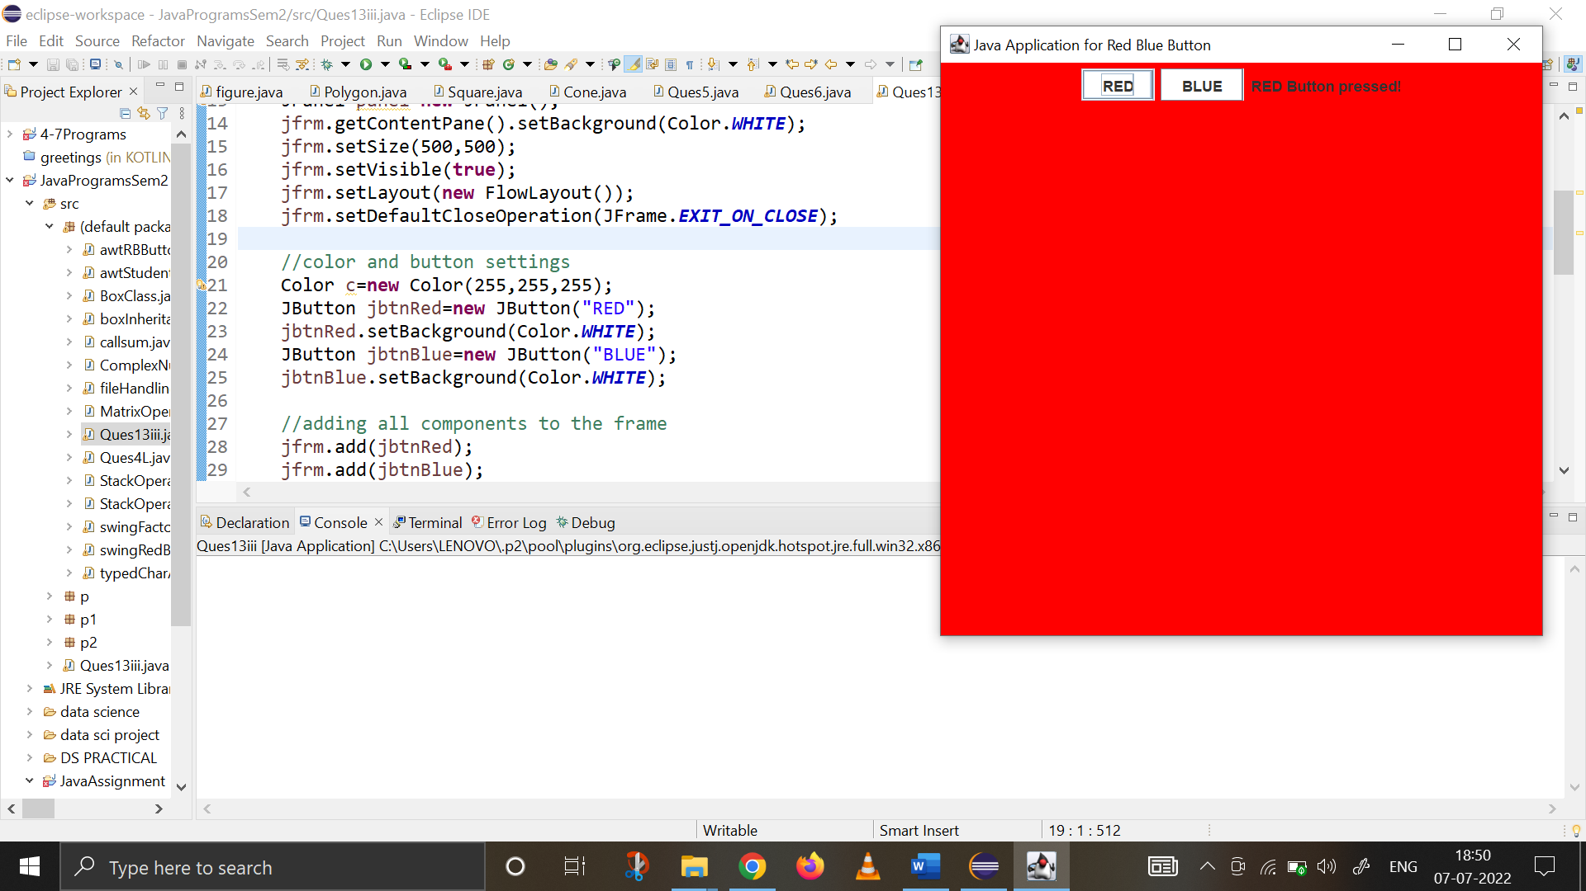

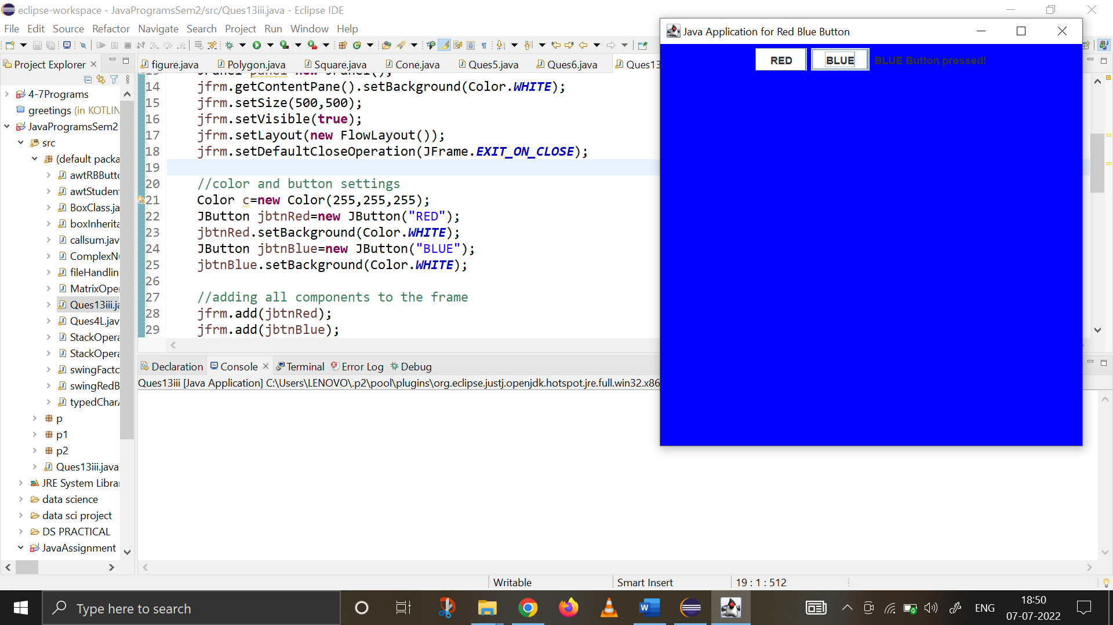

1. **Using SWING, write a program using appropriate adapter class to display the message (“Typed character is: ”) in the frame window when user types any key.**

**import** java.awt.*;

**import** java.awt.event.*;

**import** javax.swing.*;

**class** PanelK **extends** JPanel

{

String msg1= "TYPED CHARACTERS : ";

**protected** **void** paintComponent (Graphics g)

{

**super**.paintComponent(g);

g.drawString(msg1, 150, 150);

}

}

**class** MyKeyAdapter1 **extends** KeyAdapter{

PanelK o1;

MyKeyAdapter1(PanelK o2){

o1=o2;

}

**public** **void** keyTyped(KeyEvent ke)

{

o1.msg1+=ke.getKeyChar();

o1.repaint();

}

}

**class** FrameK **extends** JFrame

{

PanelK panel;

FrameK(){

**super**("Key Event Handling Swings" );

setSize(450,450);

setDefaultCloseOperation(JFrame.***EXIT_ON_CLOSE***);

getContentPane().setBackground(Color.***pink***);

panel= **new** PanelK();

add(panel);

addKeyListener(**new** MyKeyAdapter1(panel));

setVisible(**true**);

}

}

**public** **class** Ques13iv{

**public** **static** **void** main(String[] args) {

SwingUtilities.*invokeLater*(**new** Runnable() {

**public** **void** run() {

**new** FrameK();

}

});

}

}

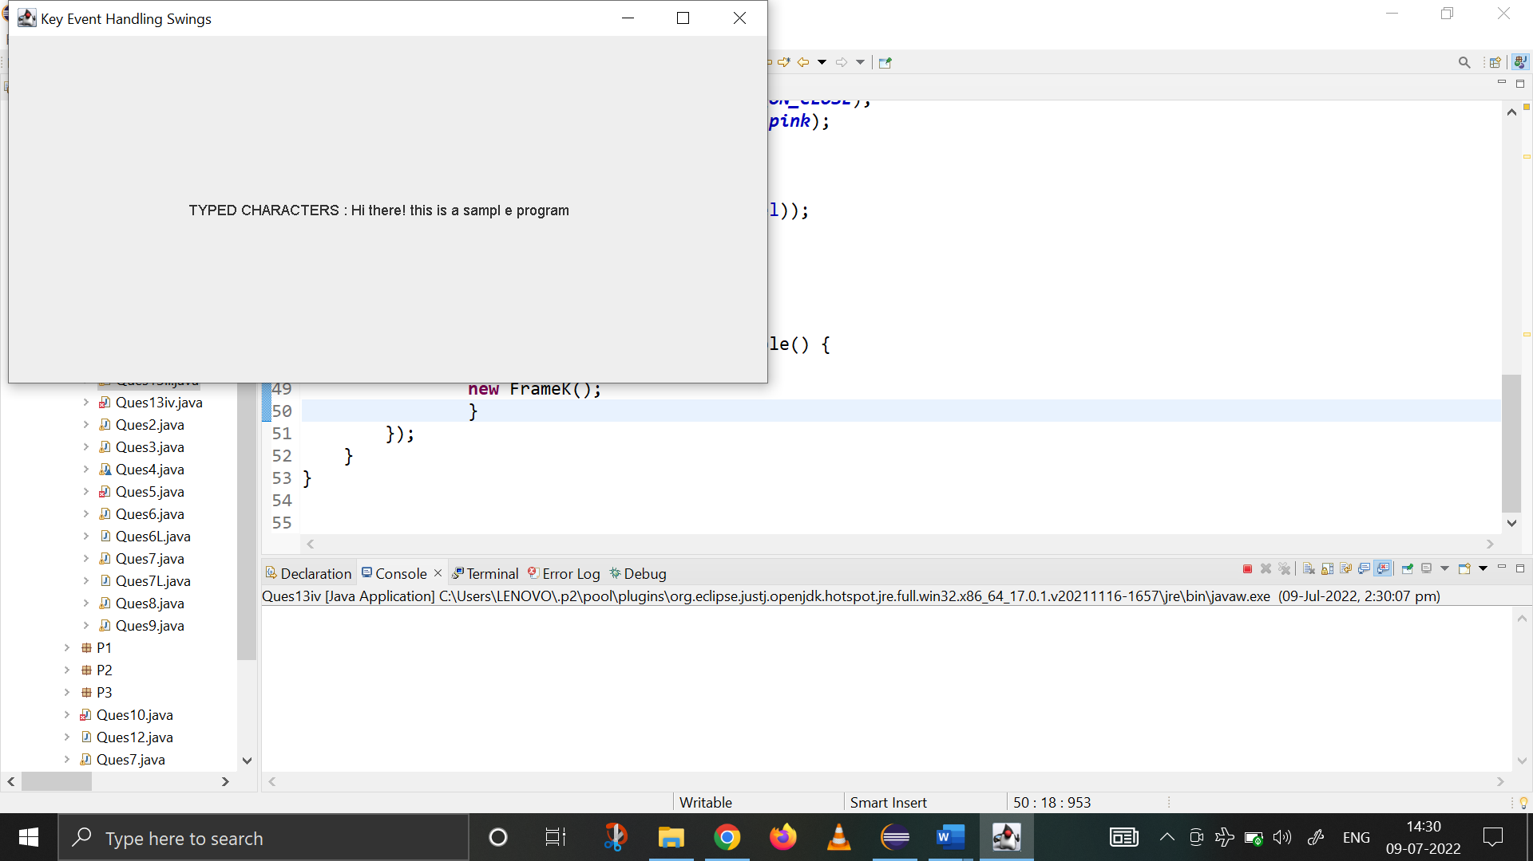

1. **Using SWING, write a program to create two buttons labelled ‘A’ and ‘B’. When button ‘A’ is pressed, it displays your personal information (Name, Course, Roll No, College) and when button ‘B’ is pressed, it displays your CGPA in previous semester.**

**import** java.awt.*;

**import** java.awt.event.*;

**import** javax.swing.*;

**class** PanelClass **extends** JPanel {

**public** String msg1="";

String msg2="";

String msg3="";

String msg4="";

**protected** **void** paintComponent(Graphics g){

**super**.paintComponent(g);

g.drawString(msg1,100,100);

g.drawString(msg2,100,120);

g.drawString(msg3,100,140);

g.drawString(msg4,100,160);

}

}

**class** Ques13v **extends** JFrame **implements** ActionListener{

JLabel label;

PanelClass panel;

Ques13v (){

panel=**new** PanelClass();

getContentPane().add(panel);

setSize(500,400);

setDefaultCloseOperation(JFrame.***EXIT_ON_CLOSE***);

JButton b1=**new** JButton("A");

JButton b2=**new** JButton("B");

b1.addActionListener(**this**);

b2.addActionListener(**this**);

panel.setLayout(**new** FlowLayout());

panel.add(b1);

panel.add(b2);

setVisible(**true**);

}

**public** **void** actionPerformed(ActionEvent ae){

String str=ae.getActionCommand();

**if**(str.equals("A")){

panel.msg1="Name : Khushi Panwar";

panel.msg2="Course : BSc.(H) Computer Sciences.";

panel.msg3="Roll no. : 2021334";

panel.msg4 ="College : Shaheed Rajguru College of Apllied Siences for Women.";

panel.repaint();

}

**else**{

panel.msg1="CGPA : 9";

panel.msg2="";

panel.msg3="";

panel. msg4="";

panel.repaint();

}

}

**public** **static** **void** main(String[] args) {

SwingUtilities.*invokeLater*(**new** Runnable() {

**public** **void** run(){

**new** Ques13v();

}

});

}

}

